Psalm 60 - A Bow, A Banner & A Battle

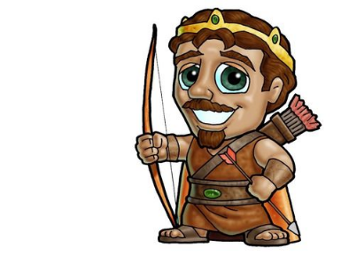
War was very different in King David’s day…..but just as scary!
Can you find the name of the nation they were fighting? E__________ v.9

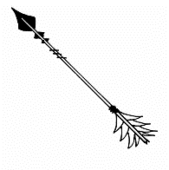
- A B_______ pulled back.
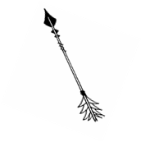
There are arrows of trouble flying everywhere!
v.1 – David realises God is a_________ - He always is with our sins!
v.2 – David describes the trouble they face like an earthquake. Can you find ‘earthquake’ words in v.2? _____________________________________________
v.3 – God has shown his people d__________ t____________
In all of this the only answer is to turn to God…… What’s David’s prayer? v.1 - R__________ us! – Bring us back to you….

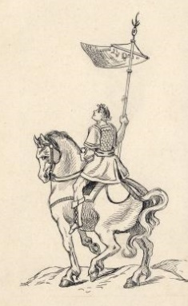
- A B____________ raised v.4
This is a B__________ like a f________ for the army to rally to. Vs.5-8 tells us lots about the Banner God raises over His people.
v.5 s_________ us – He’s our Saviour
those you L_____________ may be d__________.
v.6 God has s_______________ - His Word is always powerful.
v.7 AND God says His people are M_________ - We belong to Him!
My favourite flag is the B____________ God has raised for those that f_______ you! V.4
You could make a “Jesus is my King” Banner today!

- The B____________
v.9 – David is asking w________ will help us?
v.10 – “It is not y_______” he says to God.
v.11 – David knows that man’s help is _______________
v.12 – But with God there will be v___________
But for those who fear you, you have raised a banner to be unfurled against the bow. Psalm 60:4

What can we ask God to
help us with this week
at home?

