Luke 19:28-44

Prophecy
- What all did Jesus tell his disciples to do? (v.30-31)
- What did they discover? “They f____________ it just as he had t________ them.”

500 years previously Zechariah wrote in advance what would happen on Palm Sunday!
Look up Zechariah 9:9
Which bits of that verse tie in perfectly with today’s message in Luke?
K_________ on a D___________ coming to J___________ and having s______.

When you read things like that you realise Gods Word is T______!!

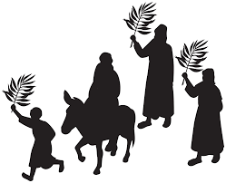

Procession
- What were the crowd praising God for?
_______________________________________________________________________
- What did they throw down on the road?
_______________________________________________________________________

In v.38 they shout about “P___________ in heaven and g________ in the highest.”
Can you think of another time those words were sung? (clue Luke 2:14)
_____________________________________________________________________________
- The crowd wanted Jesus as their K_________
- Did everyone think the same way? v.39&40 ___________________________________
- Why do you think people don’t want Jesus as their King? _______________________________________________________________________

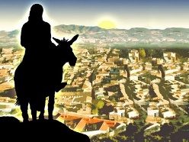
Pain (vs.41-44)
- What did Jesus do when he saw the city?
_______________________________________________________
He wasn’t upset because HE was going to die…….
He was weeping because of all that was going to happen to them.
- What did he tell them would happen? (v.43)
_______________________________________________________________________

Project for later – 40 years later in AD70 what Jesus said would happen DID happen – you can look it up online … search Jerusalem destroyed AD70.

The tragedy was that they didn’t________________________________ (v.44)

We don’t have to reject Him!
Look up John 1:12
What are we to do with Jesus? _________________________________________________
What will we become? _______________________________________________________

