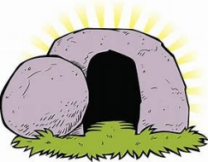
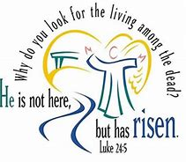
Easter Sunday!

Nearly 2000 years ago J_________ C__________ rose from the grave! When His followers met the angel at the tomb the angel said…
“ He is __________ here! He has R___________!”
Hundreds of years before that a man called Job (sounds like robe). He couldn’t have known all that Jesus would do…….BUT in Job 19:25-27 he says some pretty AMAZING things.
“I K_____________ that my R___________ lives!” (v.25)
(A ‘Redeemer’ is a person who pays the price for someone’s freedom.)
Who is our Redeemer? ____________________________________________________________
What price did He pay? ____________________________________________________________
What did God do on Easter Sunday morning to PROVE that the price of our sin had been paid?
______________________________________________________________________________________________________________________________________________________________

After my s__________ has been d_______________, yet in my f___________ I will see G_____!”
(v.26)

Job had gone through LOTS of troubles and sickness and knew that some day he’d die BUT….
He was confident that in his f___________ he’ll see God. In other words JOB believes in the
R ___s___rr___ct__on!!
Most of us will live until we’re quite old……even when we die, we don’t need to be afraid – if we’re trusting in Jesus – we’ll be given special new bodies to last forever!
Look up 1 Corinthians 15:42-44 – four words to describe these new bodies
I_______________ P_____________
G_______________ S_____________

Finally Job says “How my h___________ y_________ within me!” (to yearn means to long for / look forward to something!
What things are you looking forward to when the ‘lockdown’ ends?
_______________________________________________________________________________
Job was looking forward to the day he’ll s________ G_______!
Can you think of 4/5 things you’ll look forward to about Heaven and God’s New Creation?
_______________________________________________________________________________

